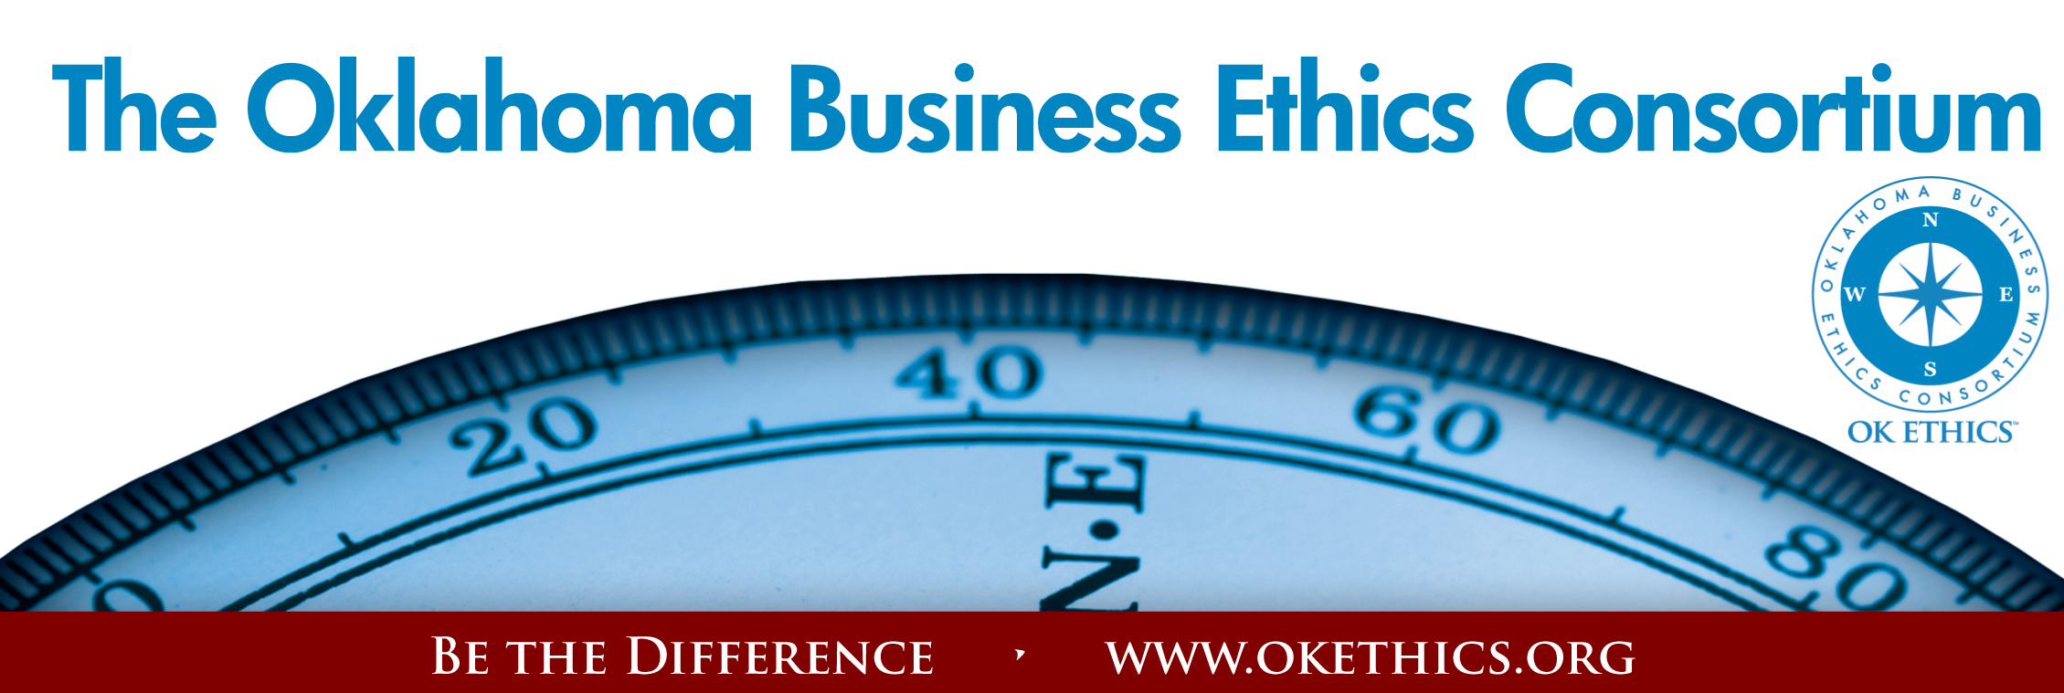

Agenda ~ Oklahoma City Chapter
January 14, 2009

I. WELCOME & GUIDING PRINCIPLE Valerie Fried, Capitol Abstract & Title Company
Founder’s Circle, OK Ethics Board of Directors
Responsibility to Self and Others:
Service:
▪ Passion for promoting ethics and integrity
▪ Encouraging the promotion of ethical behavior through personal actions and
▪ Sharing ideas and resources
▪ Responsibility and accountability for fulfilling the mission of the Consortium.
II. KUDOS Bob Byrne, Boeing
President, OK Ethics Foundation
“As we express our gratitude, we must never forget that the highest appreciation is not to utter words, but to live by them.” - John F. Kennedy
Registration Team:
- Greg Byers of Sinclair Broadcasting Group – Registration Chair.
- Mary Kay Huggard & the Principal Technologies team, including
Rebecca Deal, Ashley Warne, Holly Carattini, Jennifer Hicks
and Becky Estes.
- Deborah Gavula – OK Ethics Administrative Support

Name tags:
- Joshua Jantz – Institute of Basic Life Principles

Speaker Gifts:
Alisa Hall – The Stiletto Advantage

CPE Certificates:
Edith Steele & Colin Autin – Oklahoma Accountancy Board
Photocopies:
- Linda Manaugh – Metro Technology Centers (Handouts)
- Bobby Redinger -
Cole & Reed (Agendas)

Directions Commemorative Publication:
- Kelli Schneider – Full Force Marketing & Brand Development

Ethics of Excellence (Booklet Donations):
- Nextep, Inc.

We appreciate all of our dedicated volunteers, including those who serve on the Board.
A special welcome to the newest member of the OK Ethics Board of Directors:
Chade Nash with Gabbard & Company

Want to volunteer? Please contact Shannon Warren at warrenokla@cox.net or call 858-2233

III. UPCOMING EVENTS Shannon Warren, Founder, OK Ethics

Advance reservations required for all events ~
Visit our website at www.okethics.org or call 858-2233;
Member discounts apply regardless of location.

FEBRUARY AND MARCH EVENTS ARE RECOMMENDED FOR 1 CPE IN ETHICS

February 11

“Good Ethics for Bad Times”

What lessons have we learned about ethics from past recessions?
Examining periods of economic recession and the impact these have had on organizations in the past, Donna Miller of Executive Resource Center, LLC will facilitate an interactive program designed to help strengthen ethical decision-making skills and insights required for tough times.

Highlights include: Identifying Unique Ethical Risks During Bad Times • Communicating The Typical Warning Signs And Reasons For Bad Behavior • Learn The Reasons Why Employees Do Not Stop Or Report Bad Behavior • Staying out of Ethical Debt

Part of the program will be based on the popular Price Pritchett model of "The Excellence of Ethics".

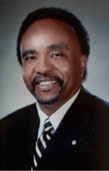
March 11
Clifton Taulbert, President of The Building Community Institute
Taulbert is one of America's leading thought-leaders on the "Power of Community" and views community in the workplace as a powerful leadership asset. Taulbert was chosen by CNN at the turn of the millennium to represent one of the voices of 'Community.' Taulbert, a Pulitzer nominated author speaks throughout the world on the critical issue of building community, a set of emotionally satisfying relationships, within all the places of our living...creating an environment branded by Respect, Affirmation and Inclusion.
Taulbert is also the author of the internationally acclaimed book, Eight Habits of the Heart, a book that provides the framework on which to build, maintain and sustain a powerful, effective and caring Community. He believes the Eight Habits of the Heart are essential for developing leadership and he conveys this message to audiences around the world.
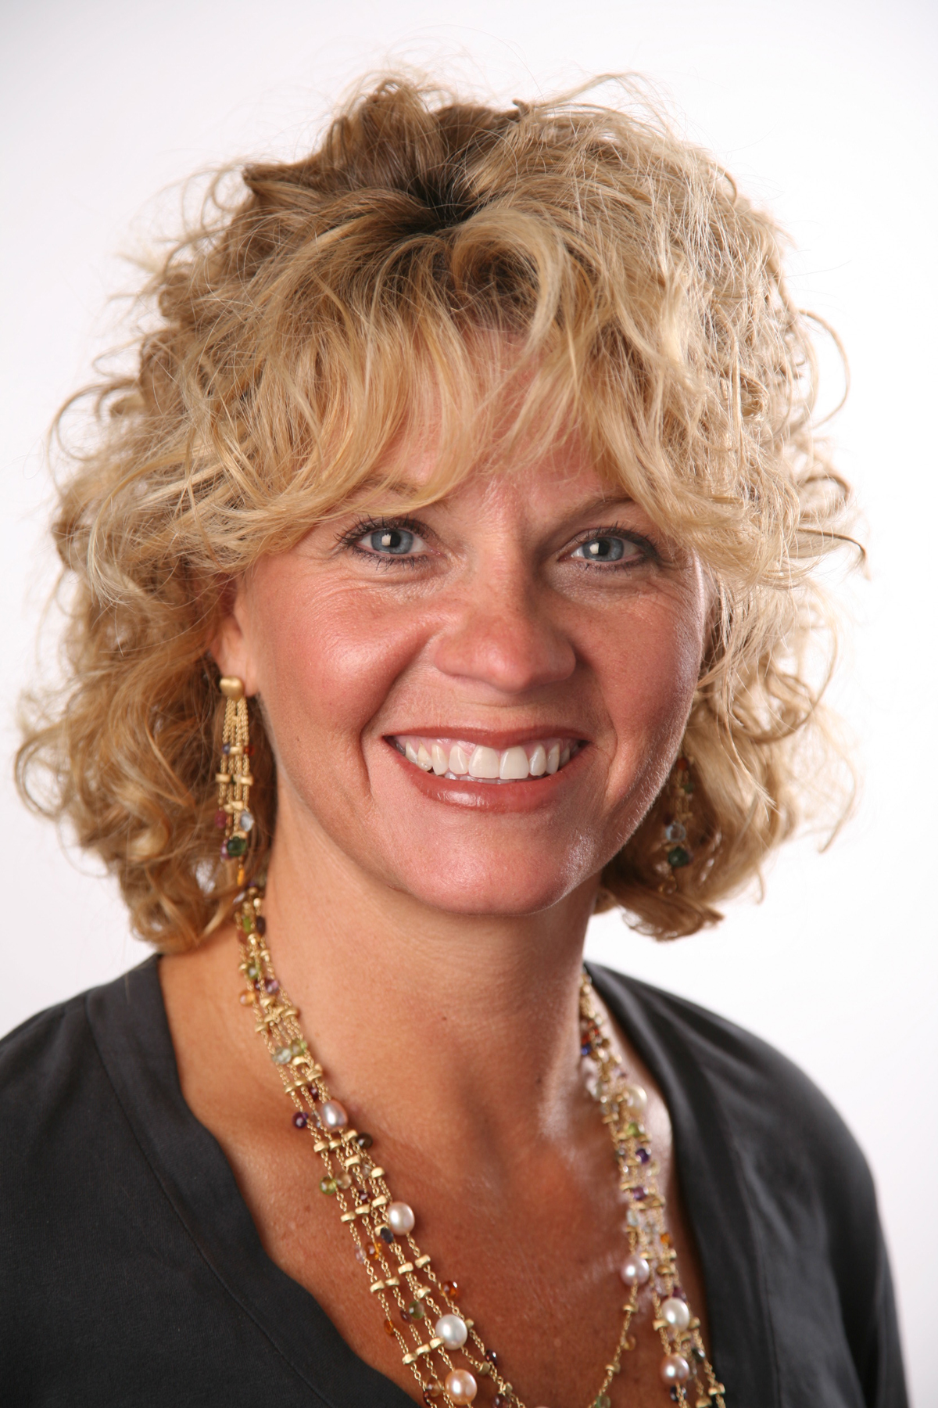

April 29 – OU Coach, Sherri Coale –
OK Ethics Statewide Compass Awards (OKC)

To be held at the new
Oklahoma Sports Hall of Fame & Jim Thorpe Museum

For more events and information about OkEthics, please visit our website at www.okethics.org or call 858-2233 or 889-0498
See also additional sponsors listed on our website.
**PRIZES**

- COMPASS AWARD – NOMINATIONS SOUGHT
At today’s meeting, we will give a Price Pritchett booklet on “The Ethics of Excellence” to the first 20 participants to nominate companies in the Oklahoma City area that have consistently exemplified strong ethical business practices. (BTW – Self nominations are strongly encouraged!)

Turn in a nomination form found on the center of your table or give us your business card with a nominee’s name on the back. Do that and a volunteer will give you a book as you exit by the registration table. (Or, do it now while you’re pondering our discussion points over lunch.)

Past Compass Award Recipients Include:
2008: BKD, LLP ~ Ideal Homes of Norman ~ Principal Technologies, Inc.
2007: Boeing ~ The Bama Companies, Inc ~ Coppermark Bank ~ Nextep, Inc.
2006: Eide Bailly ~ Valir Health

- REGISTER TO ATTEND NEXT MONTH’S MEETING
“The Ethics of Excellence” booklets will be awarded to the first 10 to register for this event and available for pick-up at the February program.

VI. DISCUSSION QUESTION
Today’s topic is “Generational Differences in Ethical Decision-Making”. To understand the differences, we need to look back at our own lives. Please go around the table, introduce yourselves and share what you believe was the most significant event shaping your life.

VII. KEYNOTE
“Generational Differences in Ethical Decision-Making”

Dr. Ken Eastman | Dr. Harry Hutson
Oklahoma State University | Devon Energy

- OTHER RELATED PROGRAMS:
CPE CERTIFICATES WILL BE ISSUED AT THE
BACK OF THE ROOM
AT THE CONCLUSION
OF THIS EVENT

YOU MUST BE REGISTERED ON OUR ATTENDANCE LIST TO RECEIVE A CERTIFICATE
NOTE THAT WE WILL NOT EMAIL THESE
PLEASE HELP US CONTROL COSTS BY LEAVING YOUR NAME TAG HERE!

Tulsa Chapter Events:
January 15
- February 26 Robyn Ewing, The Williams Cos. –
Core Values & Corporate Responsibility:
100 Years of History
- March 26 Panel Discussion –
Generations in the Workplace

Character First Institute:
OK Ethics is honored by our friendship with the Character First! Institute. They provided wisdom and the basis for our Guiding Principles. For more information on upcoming Business and Community Leaders' Luncheon, please contact them at 815-0001, or visit www.characterok.org./ Cost is $10 per person. The next topic is “Forgiveness in the Workplace” to be presented on Tuesday, January 27 or Thursday, January 29.

